Code a Tabbed Activity app that consists of three tabs. The app is to be a Career Information app for software developers. Its purpose is to provide information for applicants for employment positions within the software development field. The content for the three fragments corresponding to the three tabs are detailed below.

**First Tab/Fragment:**

The tab is to be labeled Titles.

The fragment is to consist of a selection drop-down list of job titles. For now, only five titles will be implemented. The titles are as shown below. When the user selects a title from the drop-down list and clicks the “Description” button, a description for the job title is to be provided in a TextView component. The descriptions have been provided for you as a <string-array> download on the course website.

The background image for this fragment has been provided for you to download on the course website.

Here is a screenshot of the first fragment:

|  |  |
| --- | --- |
|  |  |

**Second Tab/Fragment:**

The tab is to be labeled Terms.

The fragment is to consist of a list of terms, which brief descriptions for each term. You are to determine the descriptions. You can Google the terms and then provide a brief summary of your findings. We will start with these terms:

Agile  
 Front-end development  
 Back-end development  
 SASS  
 CMS  
 GIS  
 Progressive Web App  
 Javascript

The background for this fragment is to be a light blue, pink, or yellow color. The layout is up to you.

**Third Tab/Fragment:**

The tab is to be labeled Jobs.

The fragment is to use a web view to display a list of jobs found on indeed.com when your postal zip code is provided as a querystring parameter. For example, if you lived in River Forest, your URL would be:

<https://www.indeed.com/jobs?q=software+developer&l=60305>

You are to provide a URL that specifies your postal zip code, rather than 60305.

The output from the **.**loadURL call is to be displayed in a WebView widget display on the fragment. Be sure to specify the required Androidmanifest.xml statements.

Sample output for this fragment:

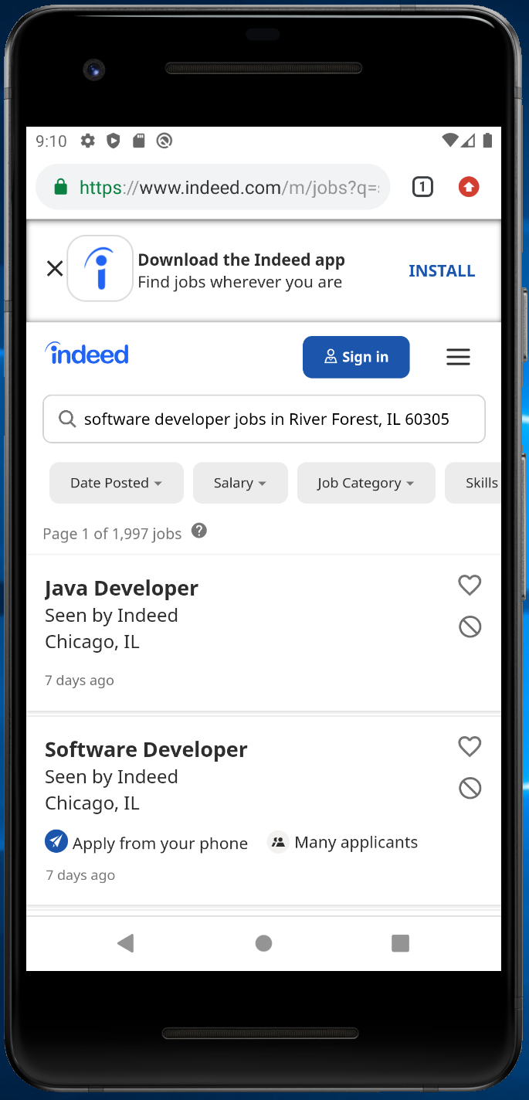

**NOTE:  Please take screenshots of your output and upload them with your zip file.  So that if I do not get the same results of your code as you have, you can possibly avoid a loss of points!**